Apex Guide: Adding RFID cards

To add Apex RFID cards to the charger. You will need to go through the following steps:

- Select the charger in the app, until presented with the page that contains the image of both the car and the charger.
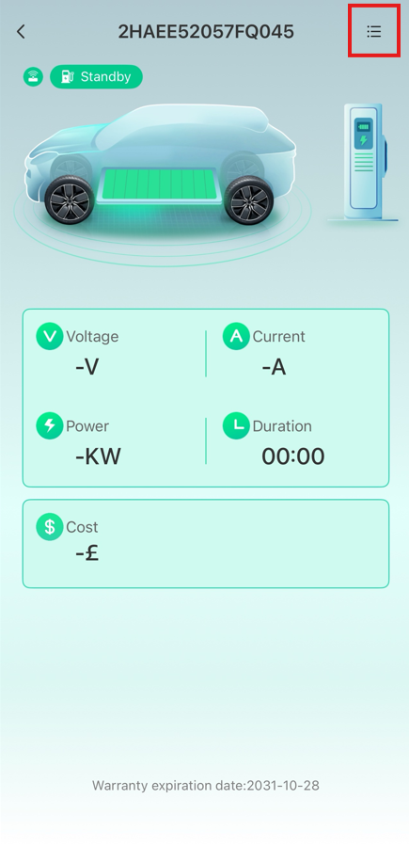
- Select the menu option as shown below:
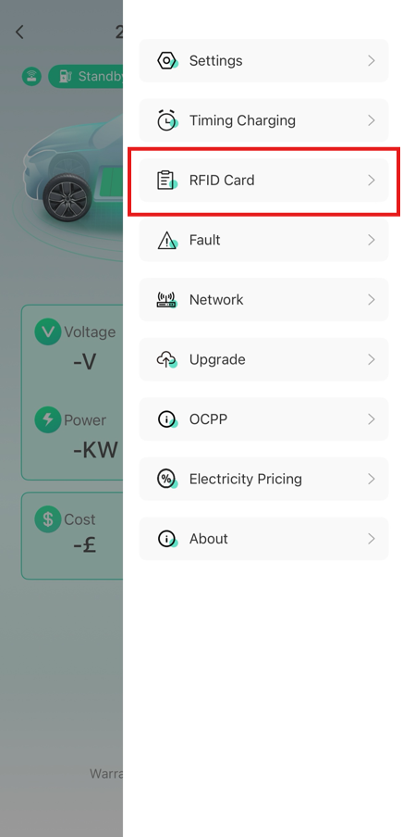
- Select RFID Card as highlighted
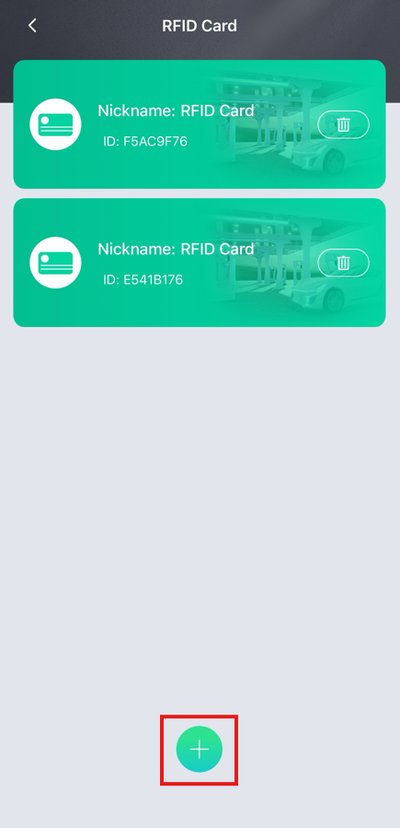
- You will be presented with the list of currently bound RFID cards, if there are any, and to add more cards, you will need to select the ‘+’ symbol as shown here
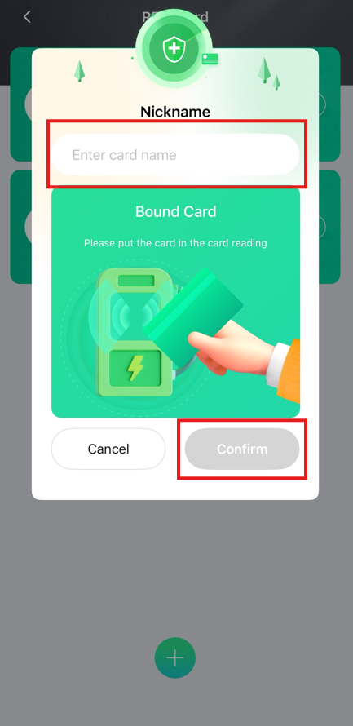
- The charger will begin to beep, and you will be presented with the bound card option. Give the card a nickname and tap the card just above the card icon on the charger. This will highlight the ‘Confirm’ button, which when pressed will add the card to the charger.

