Apex Guide: Changing the charging mode from Locked

When the charger is in locked mode, and you wish to change it to a different mode to allow for charger operation, please first remove any cables from the charger, and go through the following steps:

- Select the charger in the app, until presented with the page that contains the image of both the car and the charger.
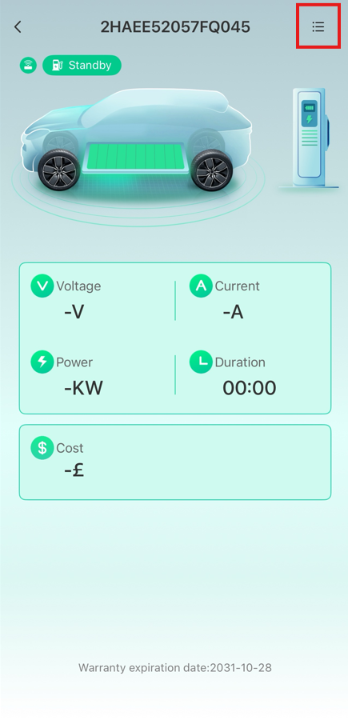
- Select the menu option as shown below:
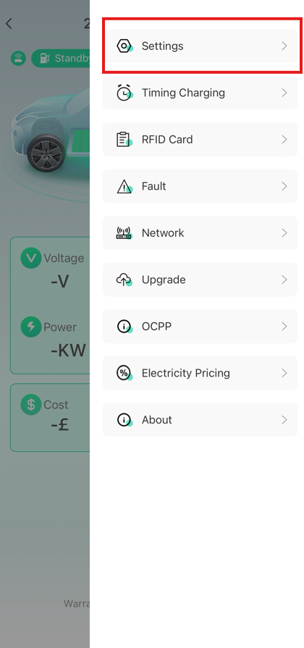
- Select settings as highlighted
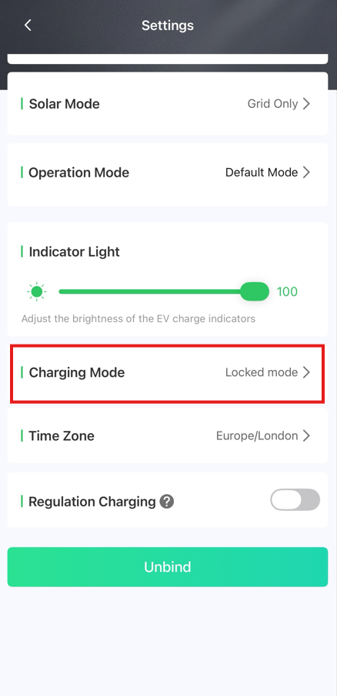
- Scroll down, and tap charging mode
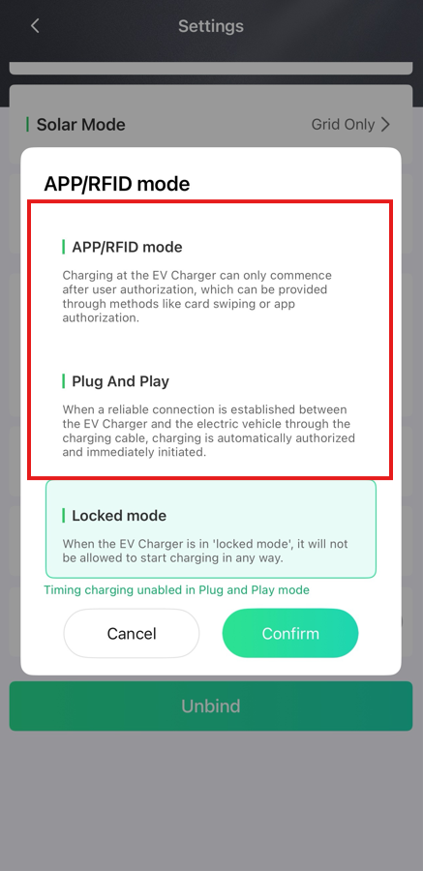
- Select either APP/RFID mode, or Plug And Play, depending on your desired charging mode. This will update the charger’s mode to make it available to use.

